**Orchestrator**

Step 1:

1. Url: [cloud.uipath.com](http://cloud.uipath.com/)
2. we need to login with the credentials if those are available
3. If credentials are not available we can login with gmail.

Step 2:

Proceed to admin tab and select Tenant option.

1. Default Tenant will be created

Need to delete the default tenant because our created robots will not be reflected in this tenant

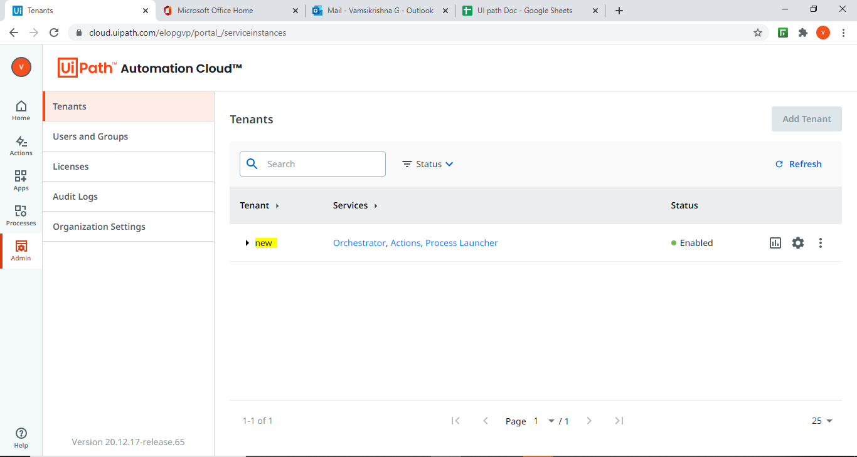

After creation of tenant we need to click on the orchestrator Then the page will redirect to the home page of orchestrator or we can see the created tenant on the home page

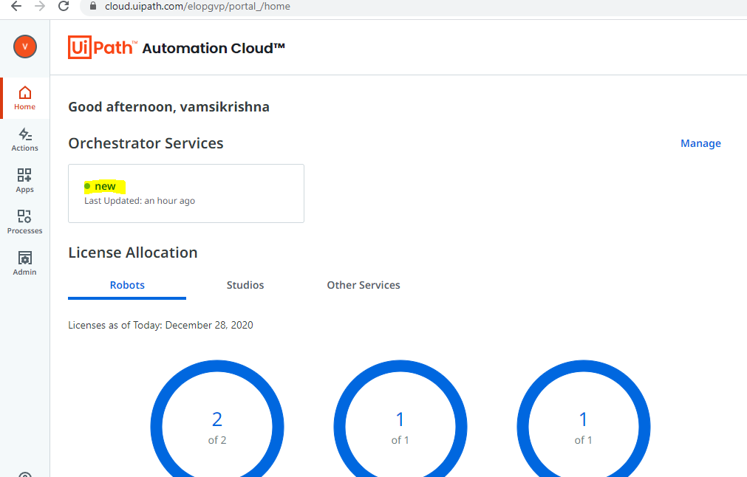

This will take to the home page

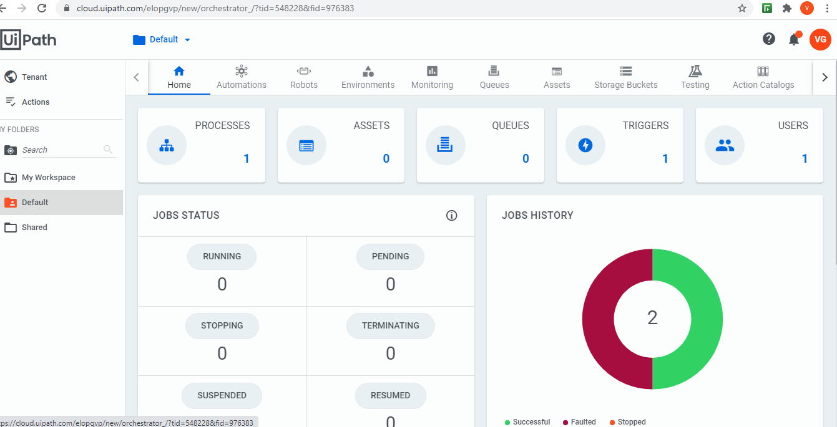

After entering in to the home page we need to create in the sequence

1. Machine
2. Robot
3. Environment
4. Process
5. Trigger & Job

**Machine:**

We can find the machine in the tenant in that we need to create the machine 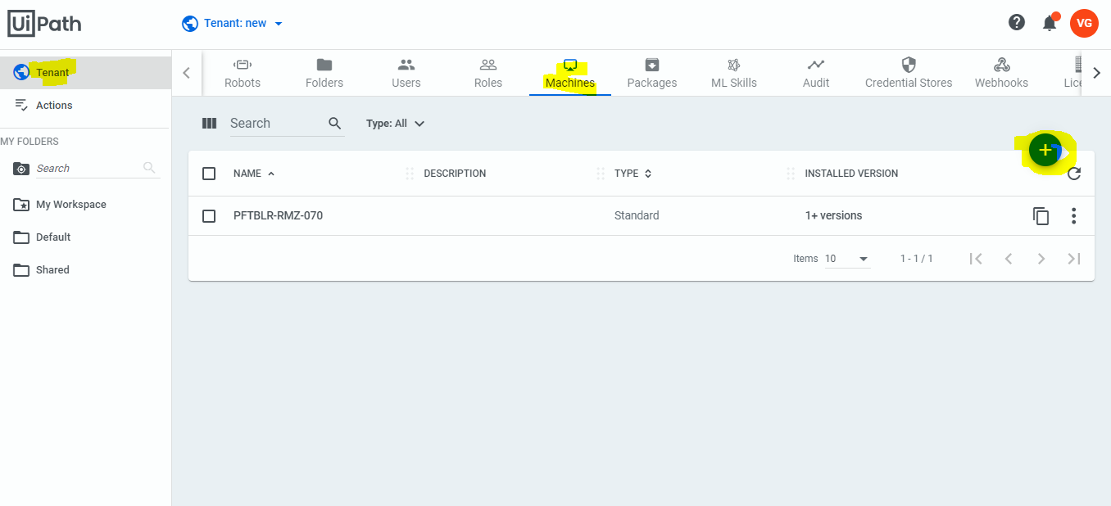

After clicking on the + icon and need to create a standard machine . it will redirect to the create machine page in that machine name should be our hostname which we can get from cmd prompt after entering the host name we need to click on the provision.as we are using community edition we can only create one machine.



**Robot:**

After creating the machine we need to create a robot of the machine . We have to click on the default folder then we are able to identify the robot on the top of the tool bar once we click on the robot we are able see the create icon then we need to click on the standard robot the we are able to see the robot creation page

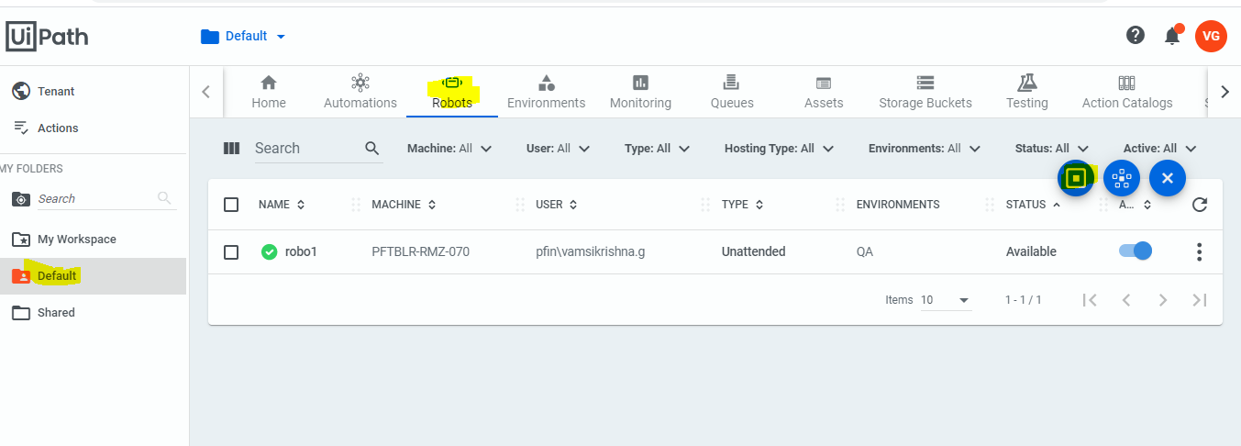

Once this create page is open there the created machine will be populated on the machine name. After that name will be your system name which we can get in the cmd prompt by typing whoami in the cmd. After that we need to give the type of the robot which should be attended or unattended because we are using the community edition so for the testing purpose we need to use unattended robots after selecting that we need to provide the Domain (system credentials) and password so that it will be accessing the machine.

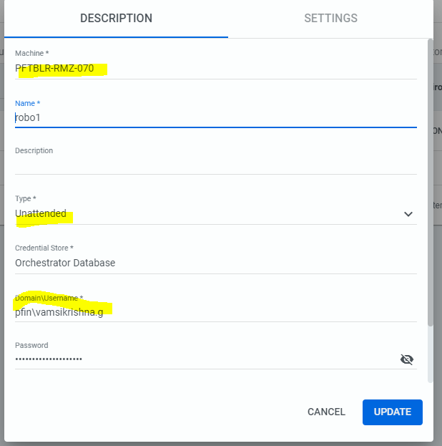

After creating the robot it will be in the disconnected state so we need to connect the robot to the machine once this robot is connected (orchestrator )is connected then we are able to run the bot .

**Connecting Robot to Machine**:

For connecting the orchestrator robot to machine we need to click on the toolbar tray there we are able to find the uipath icon after clicking that we will be finding preference in the orchestrator in that we need to configure connection type as machine key then we arable to find the orchestrator url and machine key

Url : for the orchestrator url we need to Click on the ui path home then we are able to see the linkin the search bar from that search bar we need to take the link till Tenant

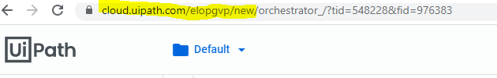

Machine key would be the key of the machine which is created please find the below

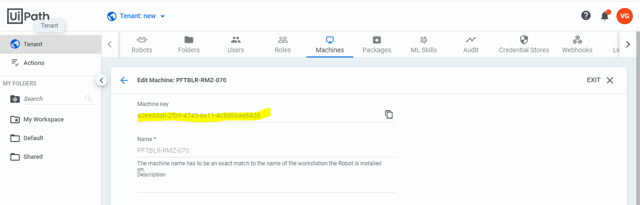

After providing the machine key we will be able to see the connect the it will be linked with the orchestrator and it will show status as connected and licensed

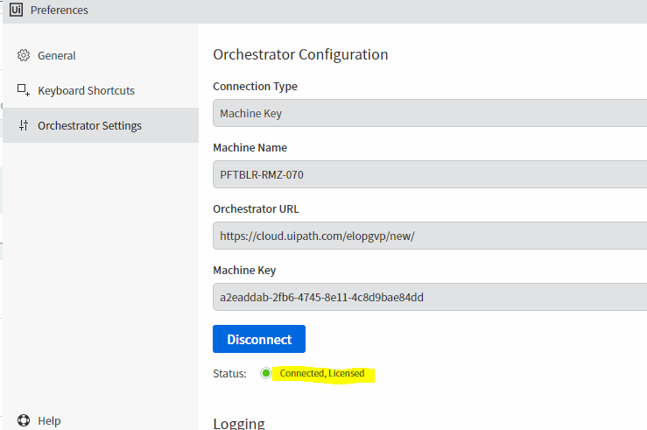

After successfully connected we will be able to see the robot is available and connected



**Environment:**

We are able to find the environment on the top of the tool bar. After the creation of the robot we need to create the environment that we need to test for this environment. We need to link the created bot .This created robot will be auto populated in the environment soon after it is created.

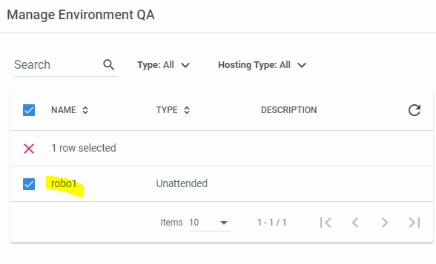

**Process:**

For the process first we need to publish the code in the UIpath then it will generate NUPKG .if this file format is not available we are not able to create the process. So we need to download the format in the uipath of manage packages we will be able to find the package of the particular format. For creating process we will be finding Automations on the toolbar will be finding process in the tab we will be finding create page from create in that we will be finding package name there we will finding + icon from that we can add package that published package is automatically populated or we will be finding in the search.if the file format is not nupkg it will not accept the file.after giving the format we will be able to create the process.

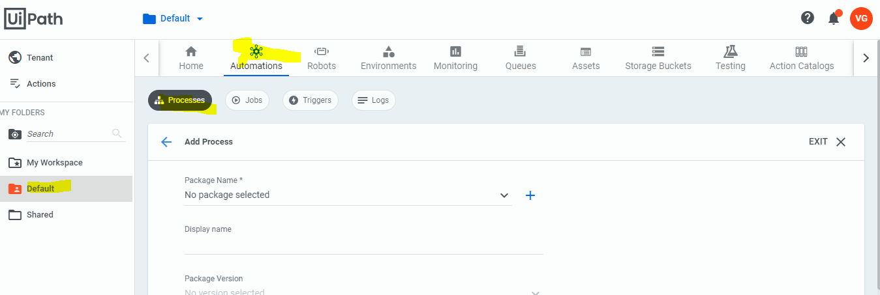

Trigger/Schedule:

Once the process is completed we will be finding the triggering option in the on the tab once click on the created we will be redirecting to the create page in that page the name we have to give the robot name and the created process will be automatically populated in the process filed and we have to give the time in 24 hrs format bases on the preference of the triggered times.After that we we need to select the robot in this we will be having the robot selection option we need to select the specific robot because if we select the all robots the process will run with all the robots or if we select the Allocate the robot dynamically there will number of robots so that it will be confused every time when it is schedule to run the process. After selecting the specific robot we will be able to see the created robots in the below section if robots are not available in the specific robots section we will be working in the wrong tenant.after selecting robot successfully we will be able to create the robot.

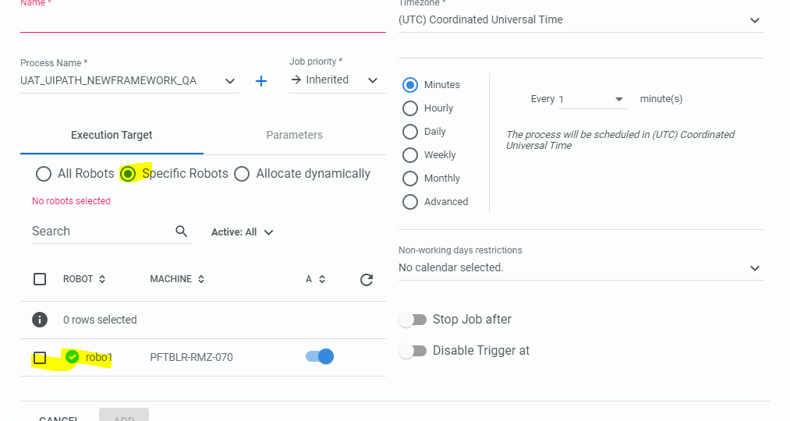

After creation of trigger in orchestrator we will able to see the ui with created trigger..

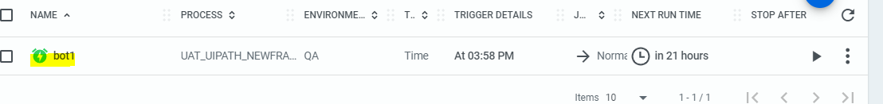

**Jobs:**

Once this process is created we will be finding the logs in the jobs

